|  |  |  |  |  |  |  |
| --- | --- | --- | --- | --- | --- | --- |
|  | | | | | | |
| **实验报告** | | | | | | |
|  | 课程名称 |  | **移动应用软件设计** |  | |  |
| 专业班级 |  |  |  | |
| 姓 名 |  |  |  | |
| 学 号 |  |  |  | |
| 联系电话 |  |  |  | |
|  |  | | | |  | |
|  |  | | | |  | |

# 实验三 Activity和Intent

## 一、实验目的

1. 了解Activity的生命周期
2. 掌握Activity的创建与注册方法
3. 理解Intent的两种形式，显式Intent和隐式Intent
4. 掌握使用Intent进行Activity间的数据传递

## 二、实验要求

1. 设计一个简易通讯录，创建两个Activity，一个用于显示联系人信息，一个用于新建联系人信息，当点击显示联系人信息界面上的“新建联系人”按钮时，跳转到新建联系人界面进行信息的填写，填写完毕后点击“完成”按钮，则所填写信息将被回显在显示联系人信息页面上。
2. 设计一个简单的浏览器，包含一个文本输入框和一个浏览按钮，文本输入框用于输入网址，单击浏览按钮即可调用浏览器打开该网页。  
   提示：调用系统的Action：ACTION_VIEW  
   添加访问网络权限：<uses-permission android:name="android.permission.INTERNET"/>

## 三、实验步骤

### **显示和编辑联系人效果图：**

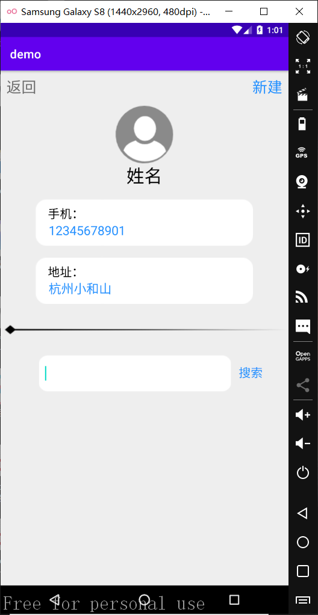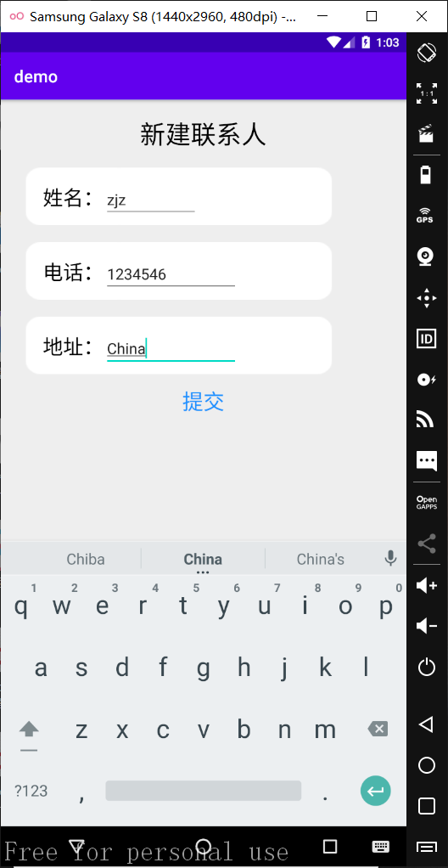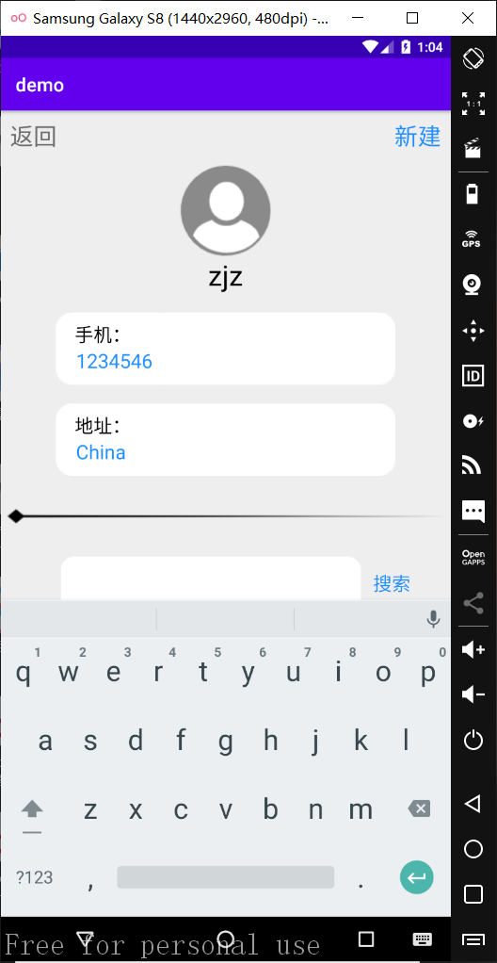

### 显示联系人layout代码：

<**TextView  
 android:id="@+id/back3_button"  
 android:layout_width="wrap_content"  
 android:layout_height="wrap_content"  
 android:text="返回"  
 android:textSize="25dp"  
 android:layout_marginTop="10dp"  
 android:layout_marginLeft="10dp"  
 android:clickable="true"** />  
<**TextView  
 android:id="@+id/btn_addmember"  
 android:layout_width="wrap_content"  
 android:layout_height="wrap_content"  
 android:text="新建"  
 android:textColor="#1e90ff"  
 android:clickable="true"  
 android:layout_alignParentRight="true"  
 android:textSize="25dp"  
 android:layout_marginRight="10dp"  
 android:layout_marginTop="10dp"**/>  
<**ImageView  
 android:id="@+id/img_head"  
 android:layout_width="wrap_content"  
 android:layout_height="wrap_content"  
 android:layout_centerHorizontal="true"  
 android:background="@drawable/headshot"  
 android:layout_below="@id/btn_addmember"  
 android:layout_marginTop="15dp"**/>  
<**TextView  
 android:id="@+id/tv_showname"  
 android:layout_width="wrap_content"  
 android:layout_height="wrap_content"  
 android:layout_centerHorizontal="true"  
 android:text="姓名"  
 android:textColor="@color/black"  
 android:textSize="30dp"  
 android:layout_below="@+id/img_head"**/>  
  
<**LinearLayout  
 android:id="@+id/linear_shownumber"  
 android:layout_width="362dp"  
 android:layout_height="77dp"  
 android:layout_below="@id/tv_showname"  
 android:layout_marginTop="20dp"  
 android:layout_centerHorizontal="true"  
 android:background="@drawable/edit_background2"  
 android:orientation="vertical"**>  
  
 <**TextView  
 android:id="@+id/tv_shownumbertitle"  
 android:layout_width="wrap_content"  
 android:layout_height="wrap_content"  
 android:layout_marginTop="10dp"  
 android:text=" 手机："  
 android:textColor="@color/black"  
 android:textSize="20dp"** />  
  
 <**TextView  
 android:id="@+id/tv_shownumber"  
 android:layout_width="wrap_content"  
 android:layout_height="wrap_content"  
 android:text=" 01234567891"  
 android:textColor="#1e90ff"  
 android:textSize="21dp"**/>  
</**LinearLayout**>  
<**LinearLayout  
 android:id="@+id/liner_showaddress"  
 android:layout_width="362dp"  
 android:layout_height="77dp"  
 android:layout_below="@id/linear_shownumber"  
 android:layout_marginTop="20dp"  
 android:layout_marginBottom="20dp"  
 android:layout_centerHorizontal="true"  
 android:background="@drawable/edit_background2"  
 android:orientation="vertical"**>  
  
 <**TextView  
 android:id="@+id/tv_showaddtitle"  
 android:layout_width="wrap_content"  
 android:layout_height="wrap_content"  
 android:layout_marginTop="10dp"  
 android:text=" 地址："  
 android:textColor="@color/black"  
 android:textSize="20dp"** />  
  
 <**TextView  
 android:id="@+id/tv_showadd"  
 android:layout_width="wrap_content"  
 android:layout_height="wrap_content"  
 android:text=" 杭州小和山"  
 android:textColor="#1e90ff"  
 android:textSize="21dp"**/>  
</**LinearLayout**>

### 显示联系人逻辑代码：

**public class** ShowMembersActivity **extends** AppCompatActivity **implements** View.OnClickListener {  
  
 @Override  
 **protected void** onCreate(Bundle savedInstanceState) {  
 **super**.onCreate(savedInstanceState);  
 setContentView(R.layout.***show_member_layout***);  
  
 Intent intent = getIntent();  
 TextView name = (TextView)findViewById(R.id.***tv_showname***);  
 TextView number = (TextView)findViewById(R.id.***tv_shownumber***);  
 TextView address = (TextView)findViewById(R.id.***tv_showadd***);  
 name.setText(intent.getStringExtra(**"MemberName"**)==**null**?**"姓名"**:intent.getStringExtra(**"MemberName"**));  
 number.setText(**" "**+(intent.getStringExtra(**"MemberNumber"**)==**null**?**"12345678901"**:intent.getStringExtra(**"MemberNumber"**)));  
 address.setText(**" "**+(intent.getStringExtra(**"MemberAddress"**)==**null**?**"杭州小和山"**:intent.getStringExtra(**"MemberAddress"**)));  
  
 TextView addmember = (TextView)findViewById(R.id.***btn_addmember***);  
 addmember.setOnClickListener(**this**);  
 TextView back = (TextView)findViewById(R.id.***back3_button***);  
 back.setOnClickListener(**this**);  
 TextView search = (TextView)findViewById(R.id.***btn_show_search***);  
 search.setOnClickListener(**this**);  
 }  
  
 @Override  
 **public void** onClick(View v) {  
 **switch** (v.getId()) {  
 **case** R.id.***back3_button***:{  
 Intent intent = **new** Intent(**this**, HomeActivity.**class**);  
 startActivity(intent);  
 **break**;  
 }  
 **case** R.id.***btn_addmember***:{  
 Intent intent = **new** Intent(**this**, AddMemberAcitivity.**class**);  
 startActivity(intent);  
 **break**;  
 }  
 **case** R.id.***btn_show_search***:{  
 EditText et_url = (EditText)findViewById(R.id.***et_show_url***);  
 String url = et_url.getText().toString();  
 **if**(url.equals(**""**))  
 Toast.*makeText*(**this**,**"请输入网址！"**,Toast.***LENGTH_SHORT***).show();  
 **else** {  
 Intent intent = **new** Intent();  
 intent.setAction(**"android.intent.action.VIEW"**);  
 Uri targetUrl = Uri.*parse*(url);  
 intent.setData(targetUrl);  
 startActivity(intent);  
 }  
 }  
 }  
 }  
}

### 添加联系人layout代码：

*<?***xml version="1.0" encoding="utf-8"***?>*<**RelativeLayout  
 xmlns:android="http://schemas.android.com/apk/res/android"  
 android:layout_width="match_parent"  
 android:layout_height="match_parent"  
 android:background="#eeeeee"**>  
 <**TextView  
 android:id="@+id/tv_add_title"  
 android:layout_width="wrap_content"  
 android:layout_height="wrap_content"  
 android:text="新建联系人"  
 android:textSize="30dp"  
 android:textColor="@color/black"  
 android:layout_marginTop="20dp"  
 android:layout_centerHorizontal="true"**/>  
  
 <**LinearLayout  
 android:id="@+id/liner_add_name"  
 android:layout_width="wrap_content"  
 android:layout_height="68dp"  
 android:layout_below="@+id/tv_add_title"  
 android:layout_marginLeft="30dp"  
 android:layout_marginTop="20dp"  
 android:background="@drawable/edit_background2"  
 android:orientation="horizontal"**>  
  
 <**TextView  
 android:id="@+id/tv_add_name"  
 android:layout_width="wrap_content"  
 android:layout_height="wrap_content"  
 android:layout_marginLeft="20dp"  
 android:layout_marginTop="15dp"  
 android:text="姓名："  
 android:textColor="@color/black"  
 android:textSize="24dp"**/>  
 <**EditText  
 android:id="@+id/et_add_name"  
 android:layout_width="wrap_content"  
 android:layout_height="wrap_content"  
 android:layout_marginTop="15dp"  
 android:hint=" "**/>  
 </**LinearLayout**>  
 <**LinearLayout  
 android:id="@+id/liner_add_number"  
 android:layout_width="wrap_content"  
 android:layout_height="68dp"  
 android:layout_below="@+id/liner_add_name"  
 android:layout_marginLeft="30dp"  
 android:layout_marginTop="20dp"  
 android:background="@drawable/edit_background2"  
 android:orientation="horizontal"**>  
  
 <**TextView  
 android:id="@+id/tv_add_number"  
 android:layout_width="wrap_content"  
 android:layout_height="wrap_content"  
 android:layout_marginLeft="20dp"  
 android:layout_marginTop="15dp"  
 android:text="电话："  
 android:textColor="@color/black"  
 android:textSize="24dp"**/>  
 <**EditText  
 android:id="@+id/et_add_number"  
 android:layout_width="wrap_content"  
 android:layout_height="wrap_content"  
 android:layout_marginTop="15dp"  
 android:inputType="phone"  
 android:hint=" "**/>  
 </**LinearLayout**>  
 <**LinearLayout  
 android:id="@+id/liner_add_address"  
 android:layout_width="wrap_content"  
 android:layout_height="68dp"  
 android:layout_below="@+id/liner_add_number"  
 android:layout_marginLeft="30dp"  
 android:layout_marginTop="20dp"  
 android:background="@drawable/edit_background2"  
 android:orientation="horizontal"**>  
  
 <**TextView  
 android:id="@+id/tv_add_address"  
 android:layout_width="wrap_content"  
 android:layout_height="wrap_content"  
 android:layout_marginLeft="20dp"  
 android:layout_marginTop="15dp"  
 android:text="地址："  
 android:textColor="@color/black"  
 android:textSize="24dp"**/>  
 <**EditText  
 android:id="@+id/et_add_address"  
 android:layout_width="wrap_content"  
 android:layout_height="wrap_content"  
 android:layout_marginTop="15dp"  
 android:hint=" "**/>  
 </**LinearLayout**>  
 <**TextView  
 android:id="@+id/btn_add_submit"  
 android:layout_width="wrap_content"  
 android:layout_height="wrap_content"  
 android:clickable="true"  
 android:text="提交"  
 android:layout_below="@id/liner_add_address"  
 android:layout_marginTop="15dp"  
 android:layout_centerHorizontal="true"  
 android:textSize="25dp"  
 android:textColor="#1e90ff"**/>  
</**RelativeLayout**>

### 添加联系人逻辑代码：

**public class** AddMemberAcitivity **extends** AppCompatActivity **implements** View.OnClickListener {  
 EditText **et_name**, **et_number**, **et_address**;  
 TextView **btn_submit**;  
 @Override  
 **protected void** onCreate(Bundle savedInstanceState) {  
 **super**.onCreate(savedInstanceState);  
 setContentView(R.layout.***addmember_layout***);  
 **et_name** = (EditText)findViewById(R.id.***et_add_name***);  
 **et_number** = (EditText)findViewById(R.id.***et_add_number***);  
 **et_address** = (EditText)findViewById(R.id.***et_add_address***);  
 **btn_submit** = (TextView)findViewById(R.id.***btn_add_submit***);  
  
 **btn_submit**.setOnClickListener(**this**);  
 }  
  
 @Override  
 **public void** onClick(View v) {  
 **switch** (v.getId()) {  
 **case** R.id.***btn_add_submit***:{  
 String sMemberName = **et_name**.getText().toString(),  
 sMemberNumber = **et_number**.getText().toString(),  
 sMemberAddress = **et_address**.getText().toString();  
 **if** (sMemberName.isEmpty())  
 Toast.*makeText*(**this**,**"请输入姓名！"**,Toast.***LENGTH_LONG***).show();  
 **else if** (sMemberNumber.isEmpty())  
 Toast.*makeText*(**this**,**"请输入电话！"**,Toast.***LENGTH_LONG***).show();  
 **else if** (sMemberAddress.isEmpty())  
 Toast.*makeText*(**this**,**"请输入地址！"**,Toast.***LENGTH_LONG***).show();  
 **else** {  
 Intent intent = **new** Intent(**this**, ShowMembersActivity.**class**);  
 intent.putExtra(**"MemberName"**, sMemberName);  
 intent.putExtra(**"MemberNumber"**, sMemberNumber);  
 intent.putExtra(**"MemberAddress"**, sMemberAddress);  
 startActivity(intent);  
 }  
 }  
 }  
 }  
}

### 浏览器启动效果图：

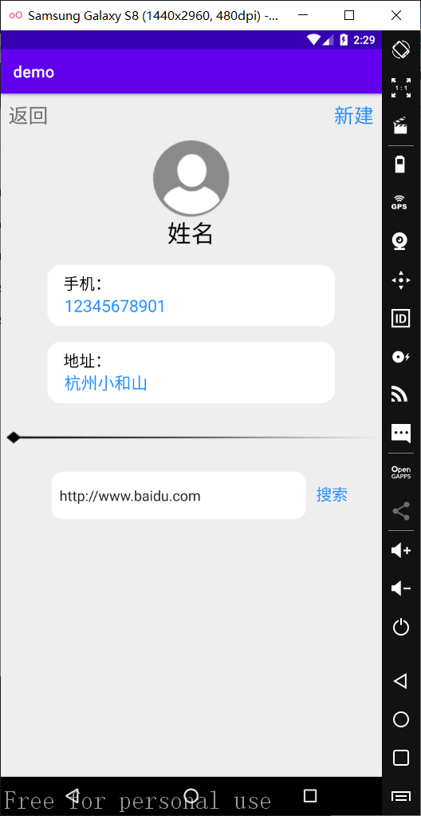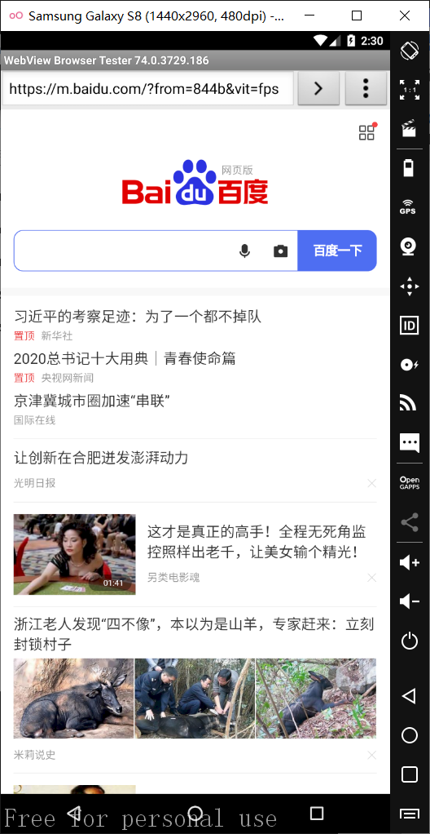

### 浏览器layout代码：

<**ImageView  
 android:id="@+id/img_divline"  
 android:layout_width="match_parent"  
 android:layout_height="wrap_content"  
 android:layout_below="@+id/liner_showaddress"  
 android:layout_marginTop="1dp"  
 android:background="@drawable/div_line"**/>  
<**LinearLayout  
 android:layout_width="wrap_content"  
 android:layout_height="wrap_content"  
 android:layout_centerHorizontal="true"  
 android:layout_below="@id/img_divline"**>  
 <**LinearLayout  
 android:id="@+id/linear_url"  
 android:layout_width="320dp"  
 android:layout_height="60dp"  
 android:layout_below="@id/img_divline"  
 android:layout_marginTop="25dp"  
 android:layout_marginLeft="22dp"  
 android:layout_marginRight="13dp"  
 android:background="@drawable/edit_background2"**>  
 <**EditText  
 android:id="@+id/et_show_url"  
 android:layout_width="296dp"  
 android:layout_height="60dp"  
 android:layout_marginLeft="10dp"  
 android:background="@drawable/edit_background2"  
 android:hint=" "** />  
 </**LinearLayout**>  
 <**TextView  
 android:id="@+id/btn_show_search"  
 android:layout_width="wrap_content"  
 android:layout_height="wrap_content"  
 android:text="搜索"  
 android:textSize="20dp"  
 android:textColor="#1e90ff"  
 android:clickable="true"  
 android:layout_below="@id/img_divline"  
 android:layout_marginTop="40dp"  
 android:layout_toRightOf="@id/linear_url"**/>  
</**LinearLayout**>

### 浏览器逻辑代码：

**public void** onClick(View v) {  
 **switch** (v.getId()) {  
 **case** R.id.***btn_show_search***:{  
 EditText et_url = (EditText)findViewById(R.id.***et_show_url***);  
 String url = et_url.getText().toString();  
 **if**(url.equals(**""**))  
 Toast.*makeText*(**this**,**"请输入网址！"**,Toast.***LENGTH_SHORT***).show();  
 **else** {  
 Intent intent = **new** Intent();  
 intent.setAction(**"android.intent.action.VIEW"**);  
 Uri targetUrl = Uri.*parse*(url);  
 intent.setData(targetUrl);  
 startActivity(intent);  
 }  
 }  
 }  
}

1. **实验报告要求**
2. 严格按照实验报告格式完成实验报告并上交
3. 按照步骤对实验过程进行截图和分析（包括核心源代码、文字说明）